# Assignment sheet for IAM

1. Create an IAM user with username of your own wish and grant administrator policy.

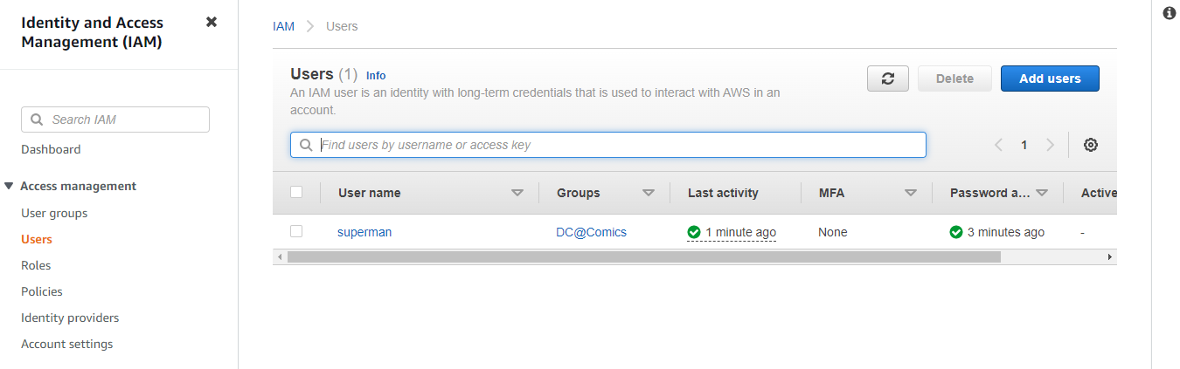

1. Create 3 Avenger Hello students, in this assignment you need to prepare a developers team of avengers .Create 3 IAM users of avengers and assign them in developer’s groups with IAM policy.

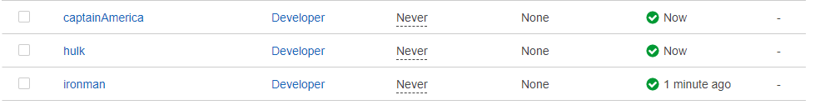

1. Assignment 4 :- Launch your linux instance in IAM and update your machine.

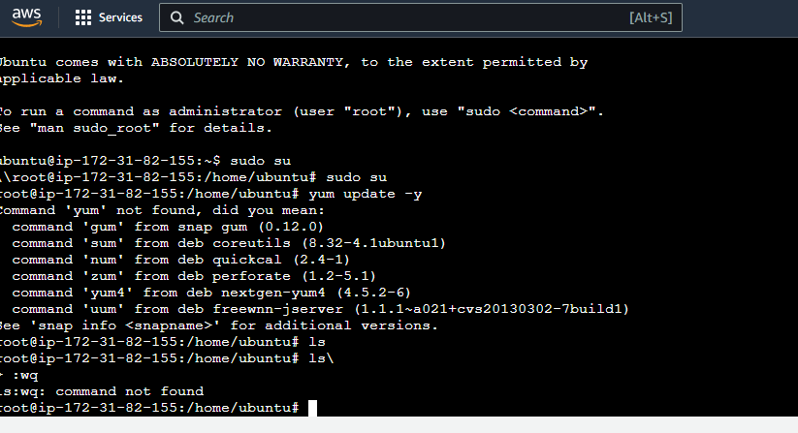

MCQ on IAM

1. Which statement best describes IAM?  
     
   a. IAM stands for Improvised Application Management, and it allows you to deploy and manage applications in the AWS Cloud.  
     
   b. IAM allows you to manage users, groups, roles, and their corresponding level of access to the AWS Platform.  
     
   c. IAM allows you to manage users' passwords only. AWS staff must create new users for your organization. This is done by raising a ticket.  
     
   d. IAM allows you to manage permissions for AWS resources only. Ans: b
2. You have created a new AWS account for your company, and you have also configured multi-factor authentication on the root account. You are about to create your new users. What strategy should you consider in order to ensure that there is good security on this account.  
     
   a. Require users to only be able to log in using biometric authentication.  
     
   b. Give all users the same password so that if they forget their password they can just ask their co-workers.  
     
   c. Restrict login to the corporate network only.  
     
   d. Enact a strong password policy: user passwords must be changed every 45 days, with each password containing a combination of capital letters, lower case letters, numbers, and special symbols. ` Ans : d
3. Using SAML (Security Assertion Markup Language 2.0), you can give your federated users single sign-on (SSO) access to the AWS Management Console.  
     
   a. False  
   b. True Ans : b
4. Which of the following is not a component of IAM?  
     
   a. Roles  
   b. Users  
   c. Organizational Units  
   d. Groups Ans : c
5. When you create a new user, that user ________.  
     
   a. Will be able to interact with AWS using their access key ID and secret access key using the API, CLI, or the AWS SDKs.  
     
   b. Will be able to log in to the console only after multi-factor authentication is enabled on their account.  
     
   c. Will only be able to log in to the console in the region in which that user was created.  
     
   d. Will be able to log in to the console anywhere in the world, using their access key ID and secret access key. Ans:d
6. A __________ is a document that provides a formal statement of one or more permissions.  
     
   a. Group  
     
   b. Policy  
     
   c. Role  
     
   d. User Ans: b
7. Every user you create in the IAM systems starts with ________.  
     
   a. Full Permissions  
     
   b. No Permissions  
     
   c. Partial Permissions Ans: b
8. What is the default level of access a newly created IAM User is granted?  
     
   a. Administrator access to all AWS services.  
     
   b. Power user access to all AWS services.  
     
   c. Read only access to all AWS services.  
     
   d. No access to any AWS services. Ans: d
9. In what language are policy documents written?  
     
   a. Node.js  
     
   b. Python  
     
   c. JSON  
     
   d. Java Ans: c
10. How many maximum access keys can be assigned to an IAM user?

(a) 1

(b) 2

(c) 3

(d) 4 Ans: b

11. IAM group:

(a) Is same as IAM users

(b) Can be used to specify permissions for a collection of users

(c) Is truly an identity

(d) All of these Ans: b

12. Temporary credentials:

(a) It expires automatically after a specified time

(b) Have a same set of permissions that your standard IAM user have

(c) We can have control over the duration that the credentials are valid

(d) A and C both Ans: d

13. AWS evaluates _______ when an IAM principal makes a request.

(a) Username and Password

(b) MAC Address

(c) Security Policies

(d) IP Address Ans: c

14. Identify the wrong statement for AWS.

(a) When a storage device has reached the end of its useful life, AWS procedures include a decommissioning process

(b) UPS units provide back-up power in the event of an electrical failure for critical and essential loads in the facility

(c) Automatic fire detection and suppression equipment has been installed to reduce risk

(d) AWS allows its user to visit physical data centers so that user can trust on it Ans: d

15. When you first create an Amazon Web Services (AWS) account, you begin with a single sign-in identity that has complete access to all AWS services and resources in the account. This identity is called:

(a) Root user

(b) Main user

(c) Super user

(d) None of these Ans: a